iSCSI Practical – AWS RHEL
Properly Arranged Step-by-Step Screenshot Guide
Topic: AWS EC2 + EBS Storage + RHEL + iSCSI Target
Order used: VPC/Networking → EC2 creation → EBS volume → SSH access → RHEL disk preparation → iSCSI target tools → FTP screenshots.
Note: The uploaded source also contains FTP screenshots, so they are kept at the end as a separate section instead of being mixed into the iSCSI sequence.

SECTION 1 — AWS NETWORKING & EC2
Step 1: Open VPC / Networking
What I did: I opened the VPC area to manage the AWS networking used by the RHEL EC2 server.
Arrow: The red arrow marks the main area to click/select in this screenshot.
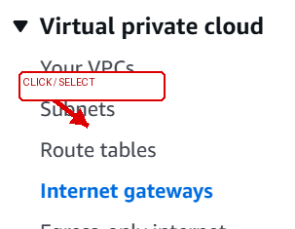
Step 1

Step 2: Review the VPC
What I did: I reviewed the VPC before creating the EC2 instance so the server would use the correct network.
Arrow: The red arrow marks the main area to click/select in this screenshot.
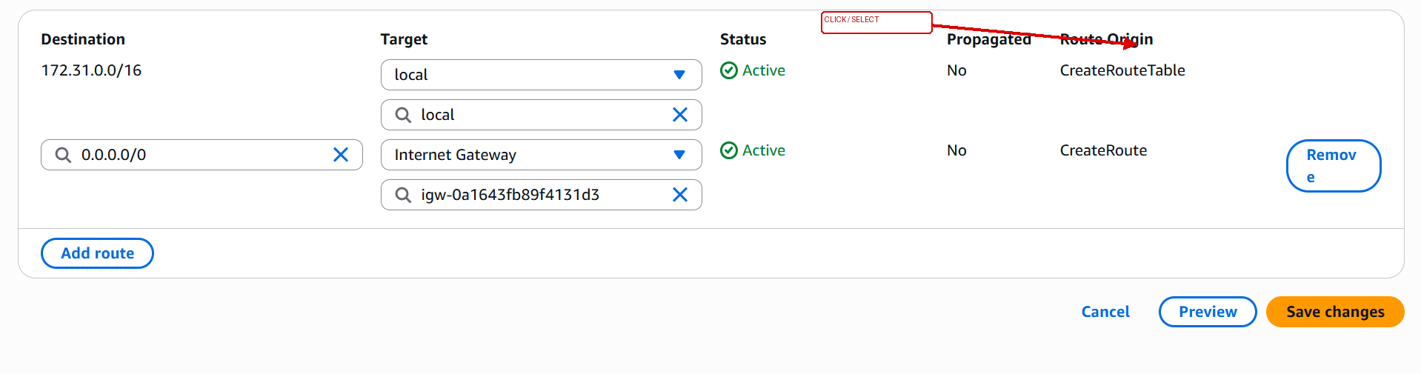
Step 2

Step 3: Review the Subnets
What I did: I checked the available subnets and their Availability Zones.
Arrow: The red arrow marks the main area to click/select in this screenshot.
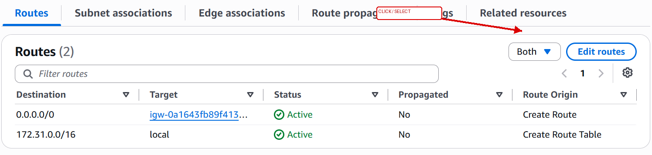
Step 3

Step 4: Open Subnets / Route Tables
What I did: I opened the subnet and route-table options used for the EC2 network.
Arrow: The red arrow marks the main area to click/select in this screenshot.
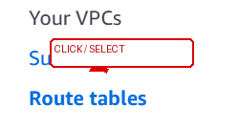
Step 4

Step 5: Review Route Tables
What I did: I reviewed the route table to verify the route used by the subnet.
Arrow: The red arrow marks the main area to click/select in this screenshot.
Step 5

Step 6: Open EC2 from Recently Visited
What I did: I opened EC2 from the AWS console to continue the server setup.
Arrow: The red arrow marks the main area to click/select in this screenshot.
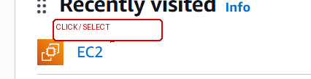
Step 6

Step 7: Open the EC2 Dashboard
What I did: I opened the EC2 dashboard where instances can be created and managed.
Arrow: The red arrow marks the main area to click/select in this screenshot.
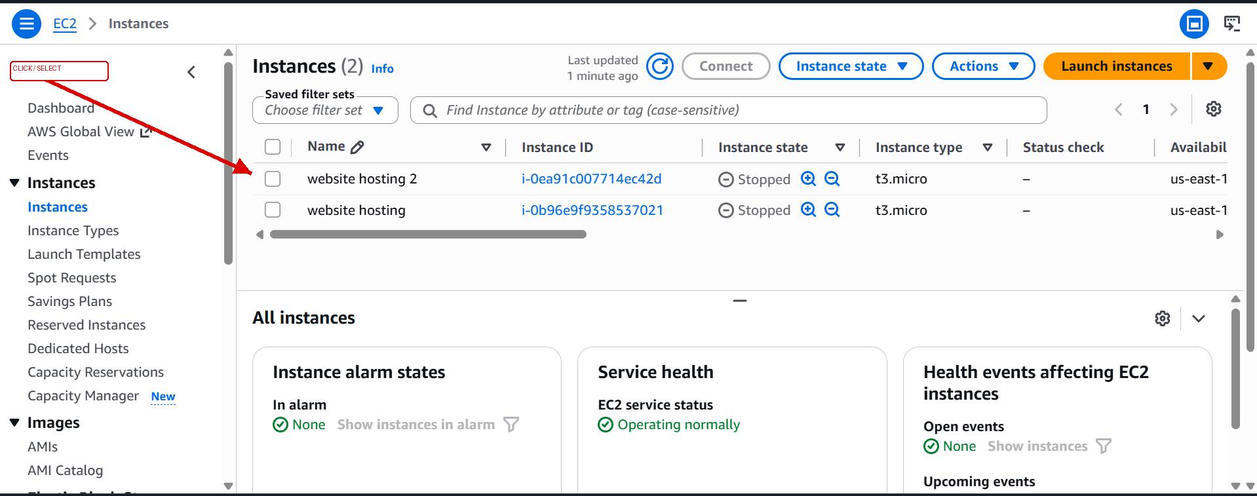
Step 7

Step 8: Start Launch Instance
What I did: I started the Launch Instance process for the RHEL server.
Arrow: The red arrow marks the main area to click/select in this screenshot.
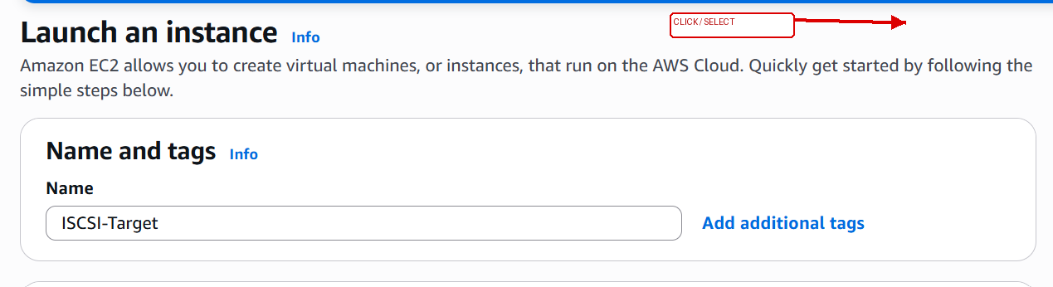
Step 8

Step 9: Select the RHEL AMI
What I did: I selected the required Red Hat Enterprise Linux AMI for the EC2 instance.
Arrow: The red arrow marks the main area to click/select in this screenshot.
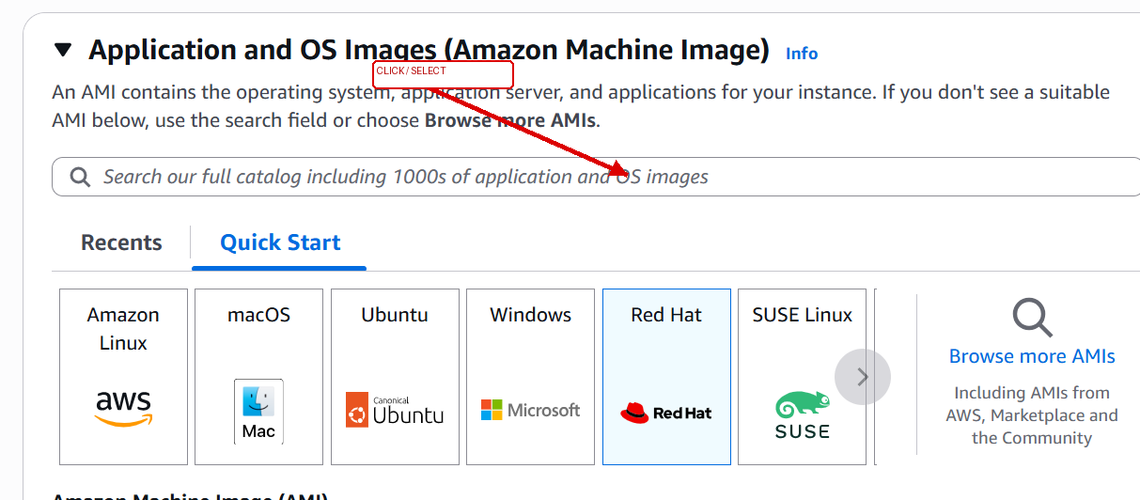
Step 9

Step 10: Select the Key Pair
What I did: I selected the EC2 key pair that will be used for secure SSH access.
Arrow: The red arrow marks the main area to click/select in this screenshot.
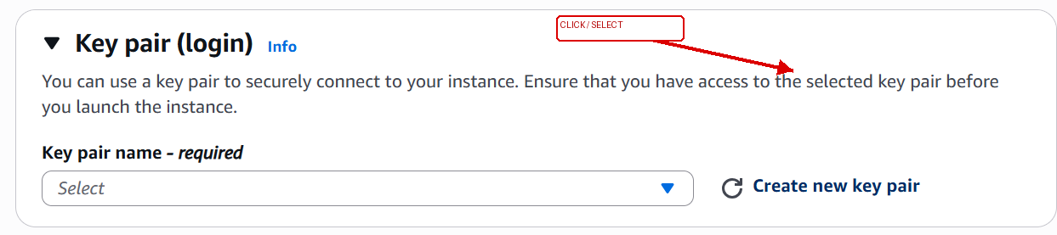
Step 10

Step 11: Create the Key Pair
What I did: I created the key pair and prepared the private .pem key for Windows SSH access.
Arrow: The red arrow marks the main area to click/select in this screenshot.
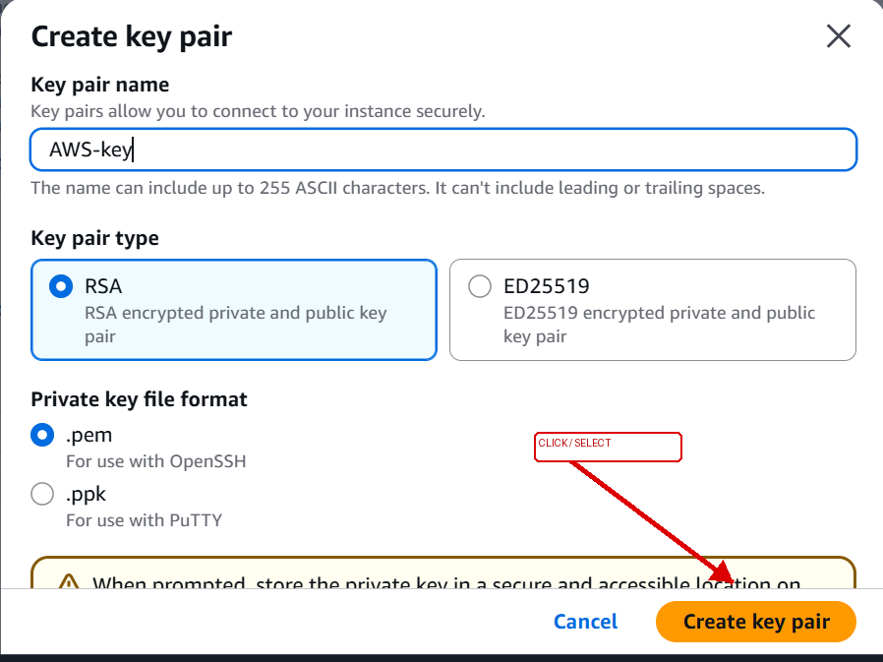
Step 11

Step 12: Configure Network Settings
What I did: I configured the VPC, subnet and public-network settings for the EC2 instance.
Arrow: The red arrow marks the main area to click/select in this screenshot.
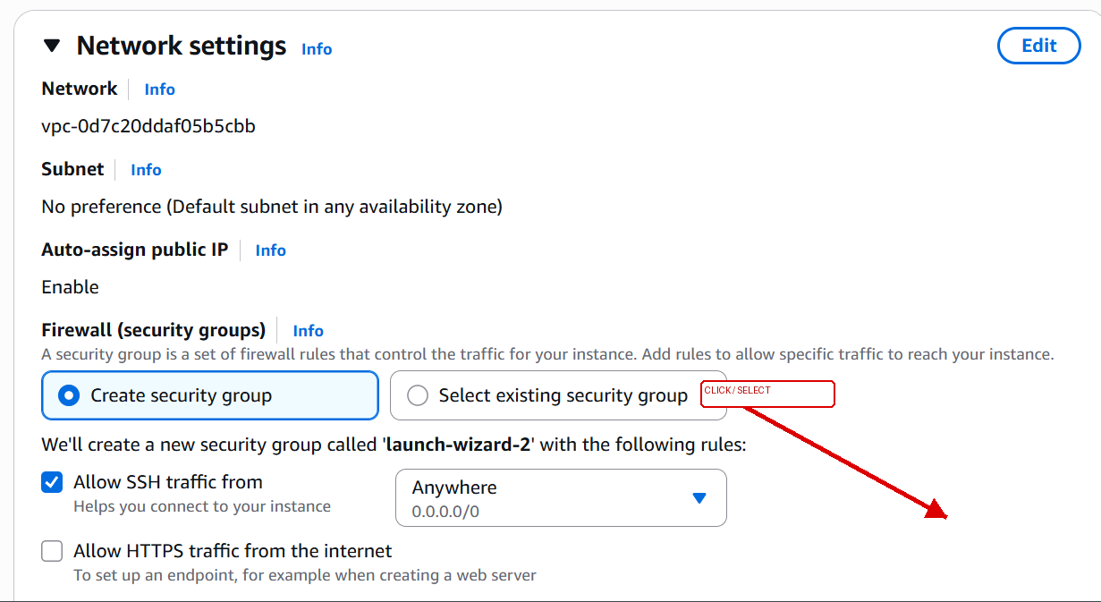
Step 12

Step 13: Configure Security Group / Network
What I did: I configured the instance network/security settings required for access.
Arrow: The red arrow marks the main area to click/select in this screenshot.
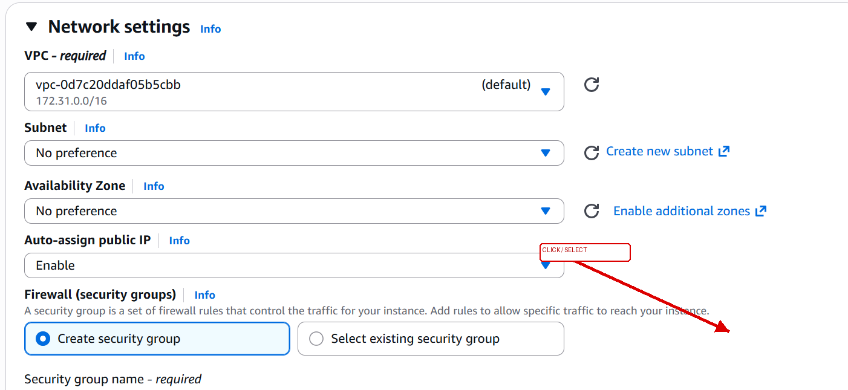
Step 13

Step 14: Review the Instance Summary
What I did: I reviewed the complete EC2 configuration before launching the instance.
Arrow: The red arrow marks the main area to click/select in this screenshot.
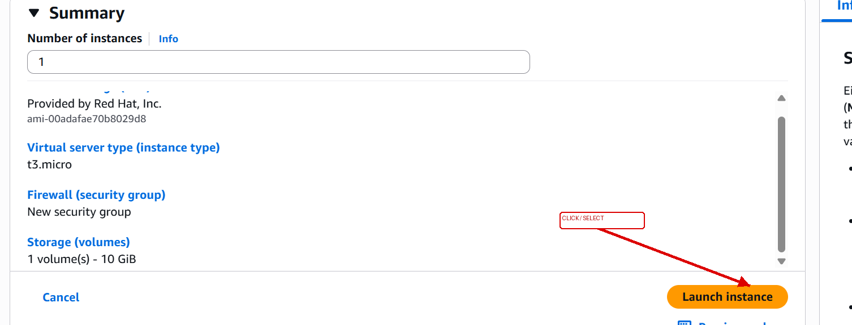
Step 14

Step 15: Launch the EC2 Instance
What I did: I launched the RHEL EC2 instance with the selected image, key pair and network settings.
Arrow: The red arrow marks the main area to click/select in this screenshot.
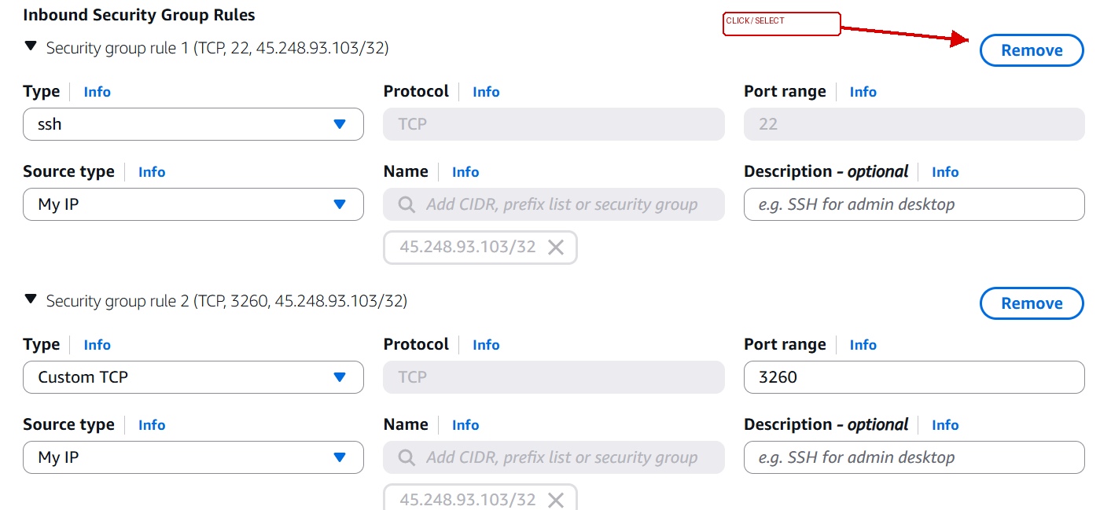
Step 15

Step 16: Confirm Successful Launch
What I did: AWS confirmed that the EC2 instance launch request was successful.
Arrow: The red arrow marks the main area to click/select in this screenshot.
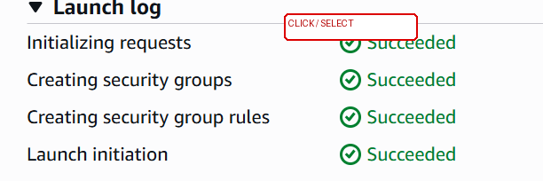
Step 16

Step 17: Open the New EC2 Instance
What I did: I opened the newly created EC2 instance to check its details.
Arrow: The red arrow marks the main area to click/select in this screenshot.
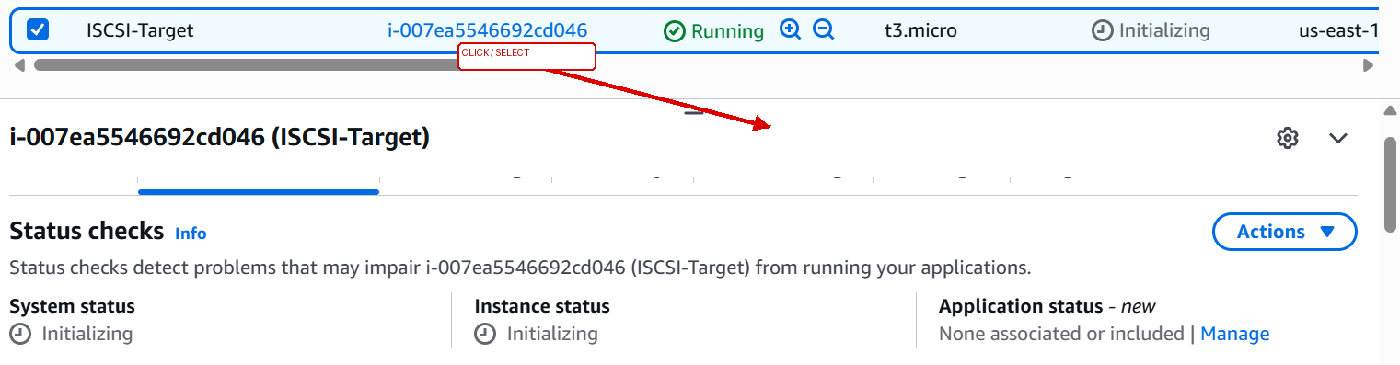
Step 17

Step 18: Verify the Running Instance
What I did: I verified the instance details and network information after launch.
Arrow: The red arrow marks the main area to click/select in this screenshot.
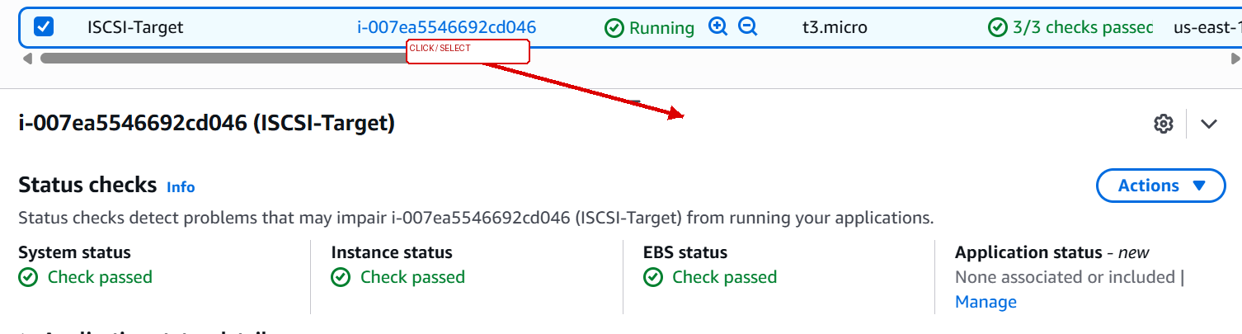
Step 18

SECTION 2 — EBS VOLUME
Step 19: Open EBS Volumes
What I did: I opened EBS Volumes to create additional storage for the practical.
Arrow: The red arrow marks the main area to click/select in this screenshot.
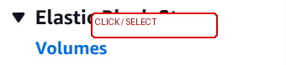
Step 19

Step 20: View EBS Volumes
What I did: I reviewed the existing EBS volumes before creating the new disk.
Arrow: The red arrow marks the main area to click/select in this screenshot.
Step 20

Step 21: Create a New Volume
What I did: I opened Create Volume and entered the required storage settings.
Arrow: The red arrow marks the main area to click/select in this screenshot.
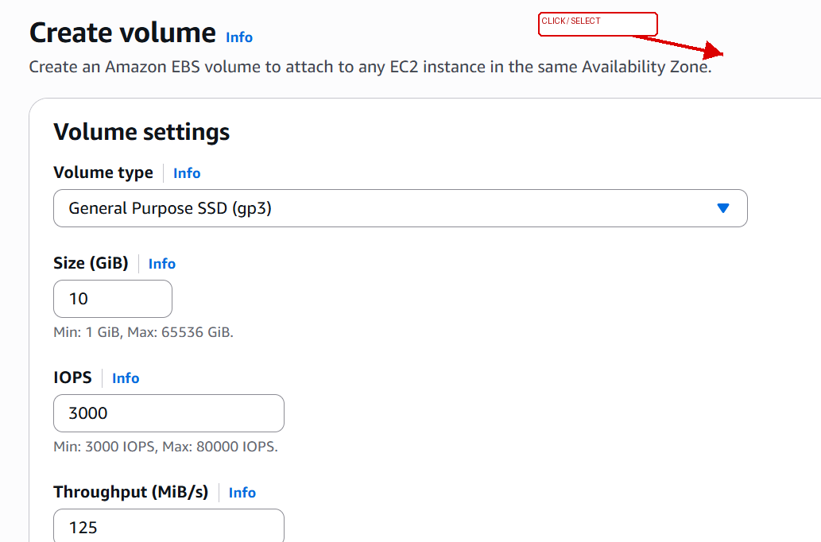
Step 21

Step 22: Select the Availability Zone
What I did: I selected the Availability Zone for the EBS volume so it can be attached to the EC2 instance.
Arrow: The red arrow marks the main area to click/select in this screenshot.
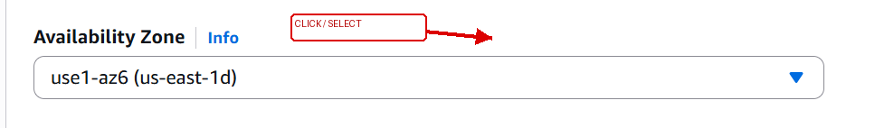
Step 22

Step 23: Review Volume Settings
What I did: I reviewed the EBS volume settings before creating it.
Arrow: The red arrow marks the main area to click/select in this screenshot.
Step 23

Step 24: Confirm the New Volume
What I did: The new EBS volume is visible in the volume list.
Arrow: The red arrow marks the main area to click/select in this screenshot.
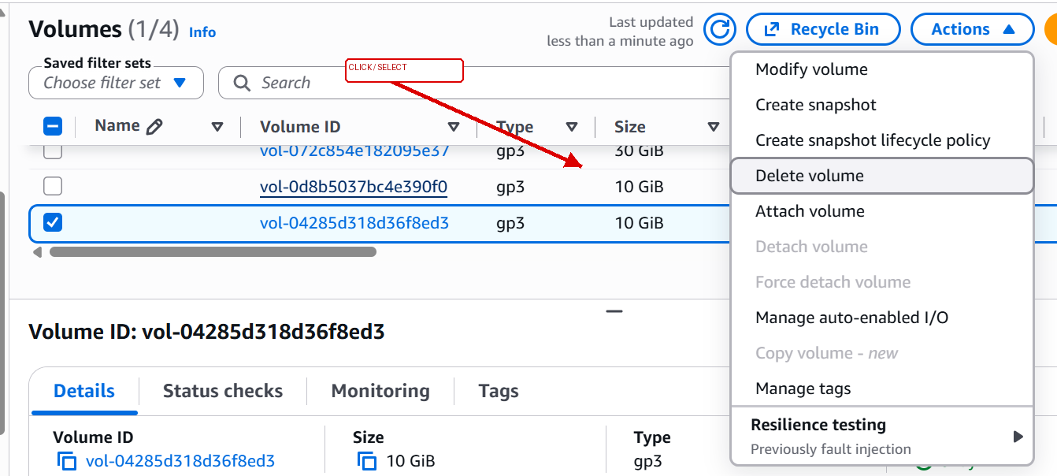
Step 24

Step 25: Attach the Volume
What I did: I opened Attach Volume to connect the EBS disk to the RHEL instance.
Arrow: The red arrow marks the main area to click/select in this screenshot.
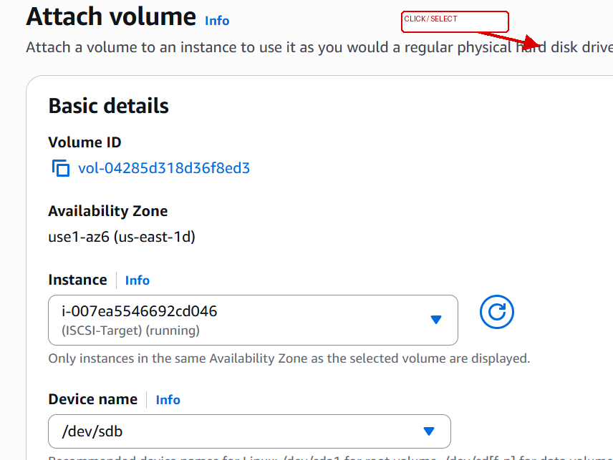
Step 25

Step 26: Select the EC2 Instance for Attachment
What I did: I selected the RHEL EC2 instance as the attachment target.
Arrow: The red arrow marks the main area to click/select in this screenshot.
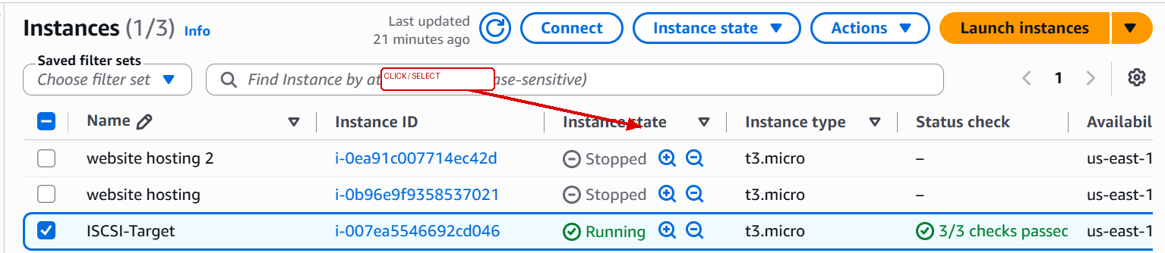
Step 26

Step 27: Verify the Attached Volume
What I did: I verified that the EBS volume was attached to the EC2 instance.
Arrow: The red arrow marks the main area to click/select in this screenshot.
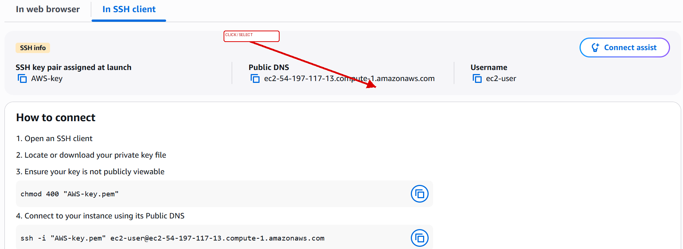
Step 27

Step 28: Open Windows Run / Command Prompt
What I did: I opened the Windows Run dialog to start the command-line access/testing process.
Arrow: The red arrow marks the main area to click/select in this screenshot.
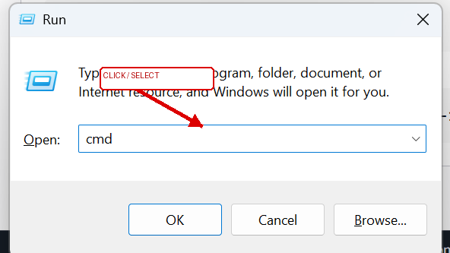
Step 28

SECTION 3 — SSH ACCESS FROM WINDOWS
Step 29: First SSH Connection Attempts
What I did: The first SSH attempts timed out or used an incorrect hostname, so network/SSH access still needed to be fixed.
Terminal note: Use the command/output shown in the screenshot as the record of this step.
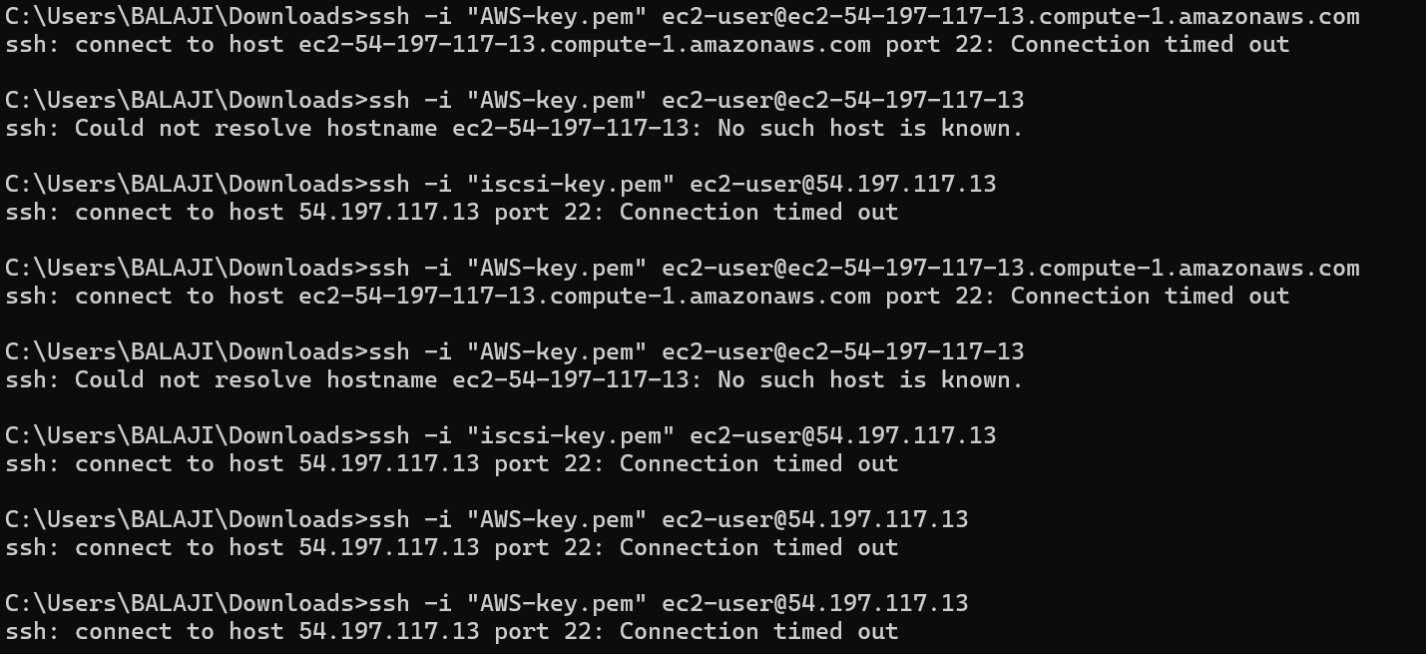
Step 29

Step 30: Test TCP Port 22
What I did: I tested TCP port 22 from Windows to check whether the SSH service was reachable.
Terminal note: Use the command/output shown in the screenshot as the record of this step.
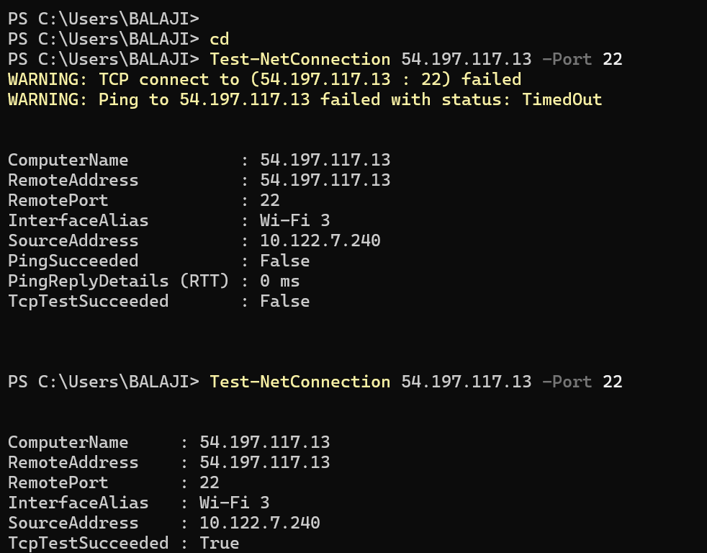
Step 30

Step 31: Accept Host Key and Check Key Permissions
What I did: After port 22 became reachable, I accepted the host fingerprint; the PEM file then showed a permissions error.
Terminal note: Use the command/output shown in the screenshot as the record of this step.
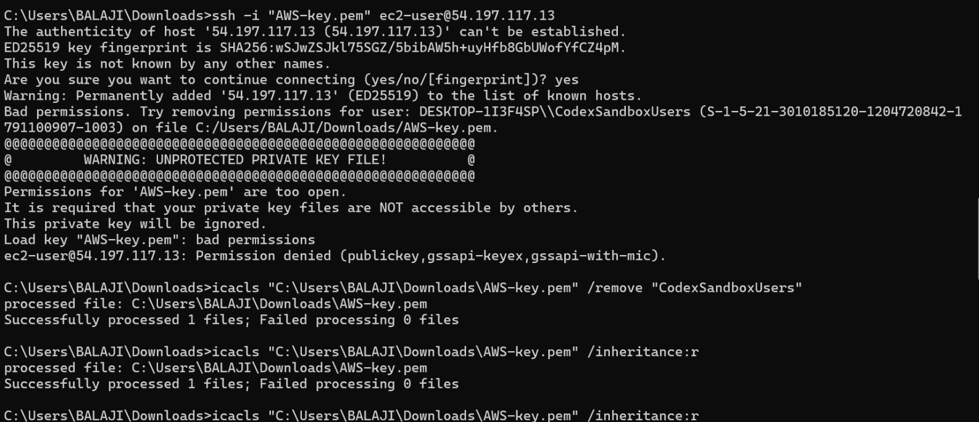
Step 31

Step 32: Fix the PEM File Permissions
What I did: I changed the Windows permissions on the AWS PEM file so SSH could read the private key securely.
Terminal note: Use the command/output shown in the screenshot as the record of this step.
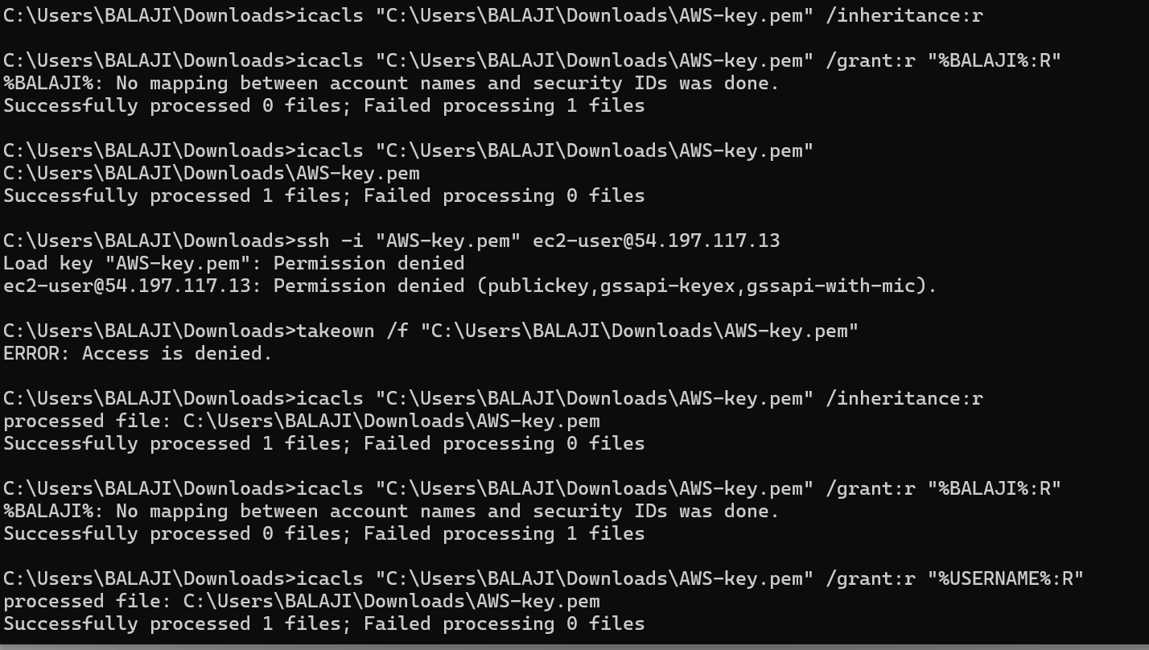
Step 32

Step 33: Successful SSH Login
What I did: SSH login succeeded and the RHEL EC2 shell became available.
Terminal note: Use the command/output shown in the screenshot as the record of this step.
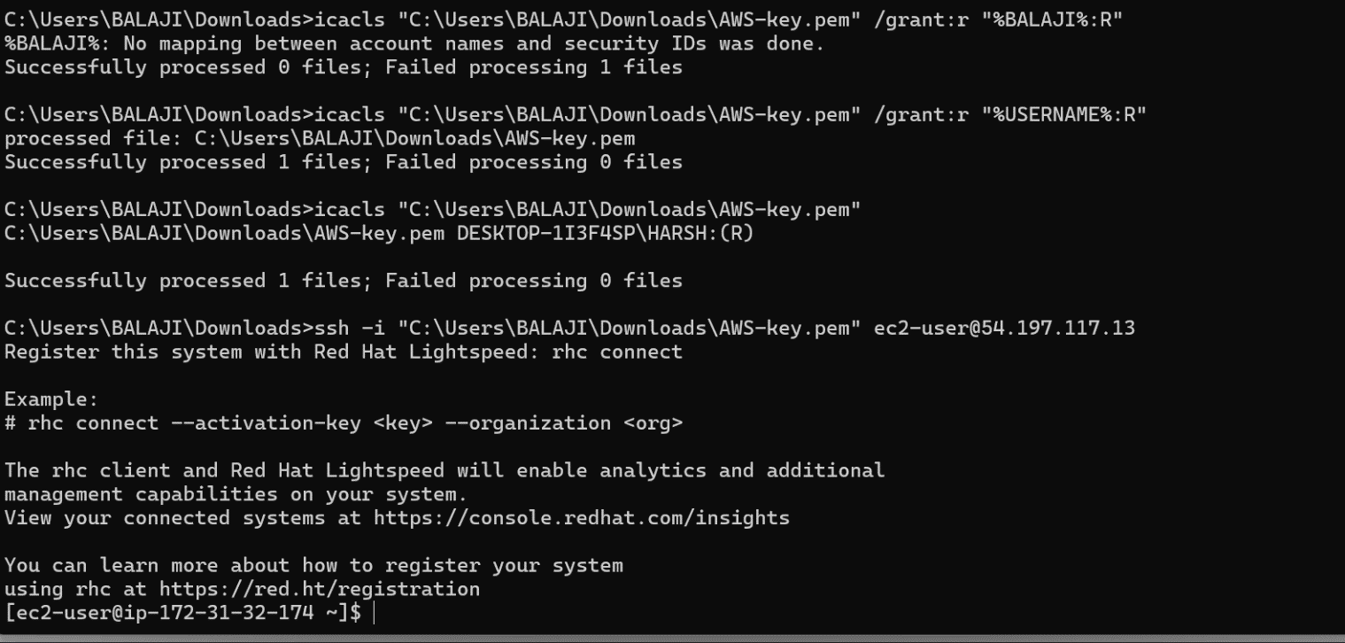
Step 33

SECTION 4 — RHEL STORAGE & iSCSI TOOLS
Step 34: Verify the New NVMe Disk
What I did: I checked the attached storage with lsblk and identified the new NVMe disk as /dev/nvme1n1.
Terminal note: Use the command/output shown in the screenshot as the record of this step.
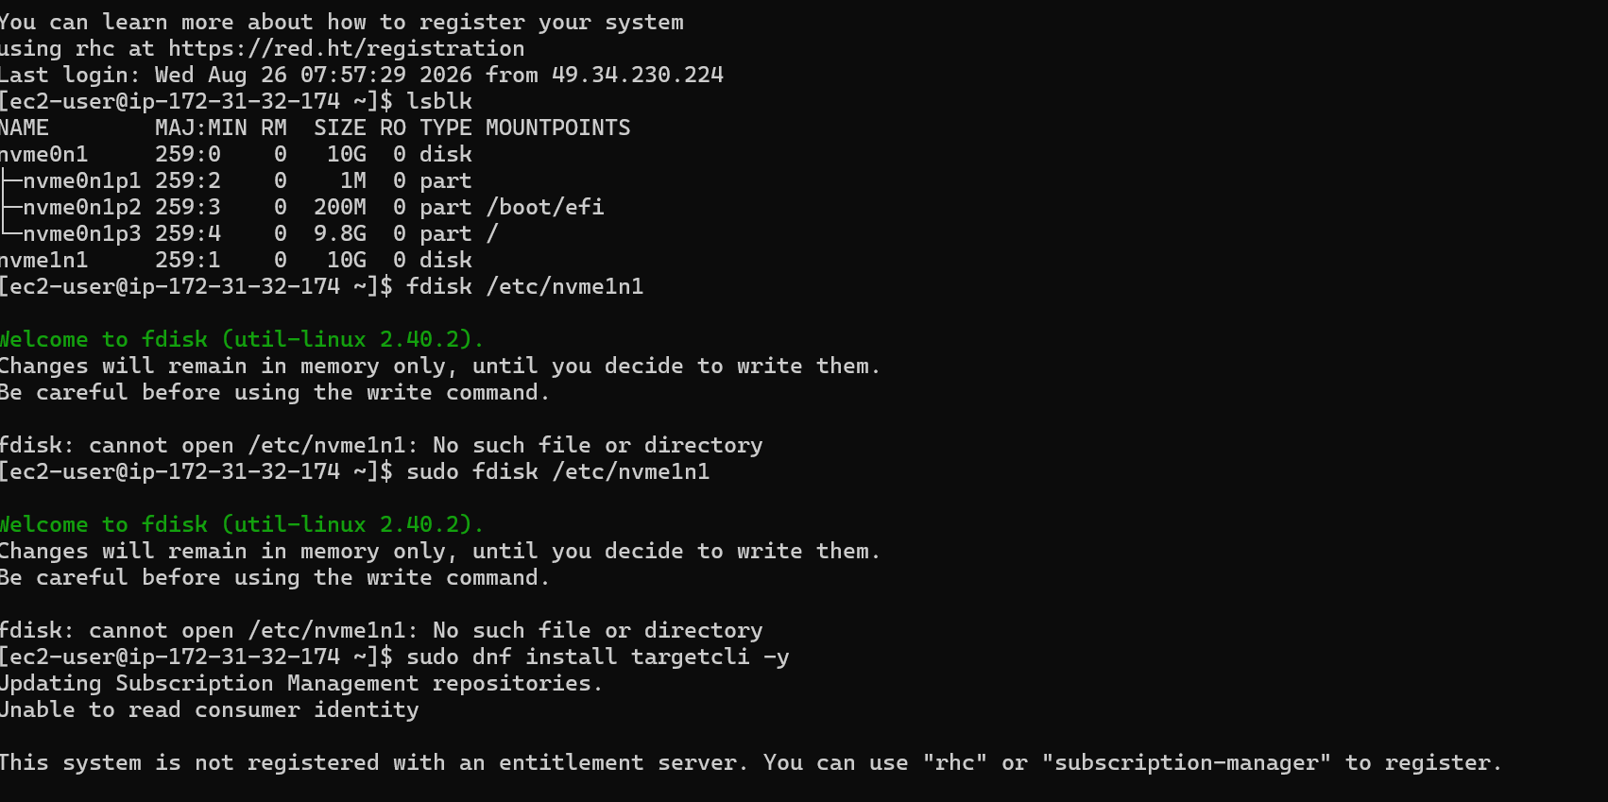
Step 34

Step 35: Create the Disk Partition
What I did: I used fdisk to create a partition on the new NVMe disk.
Terminal note: Use the command/output shown in the screenshot as the record of this step.
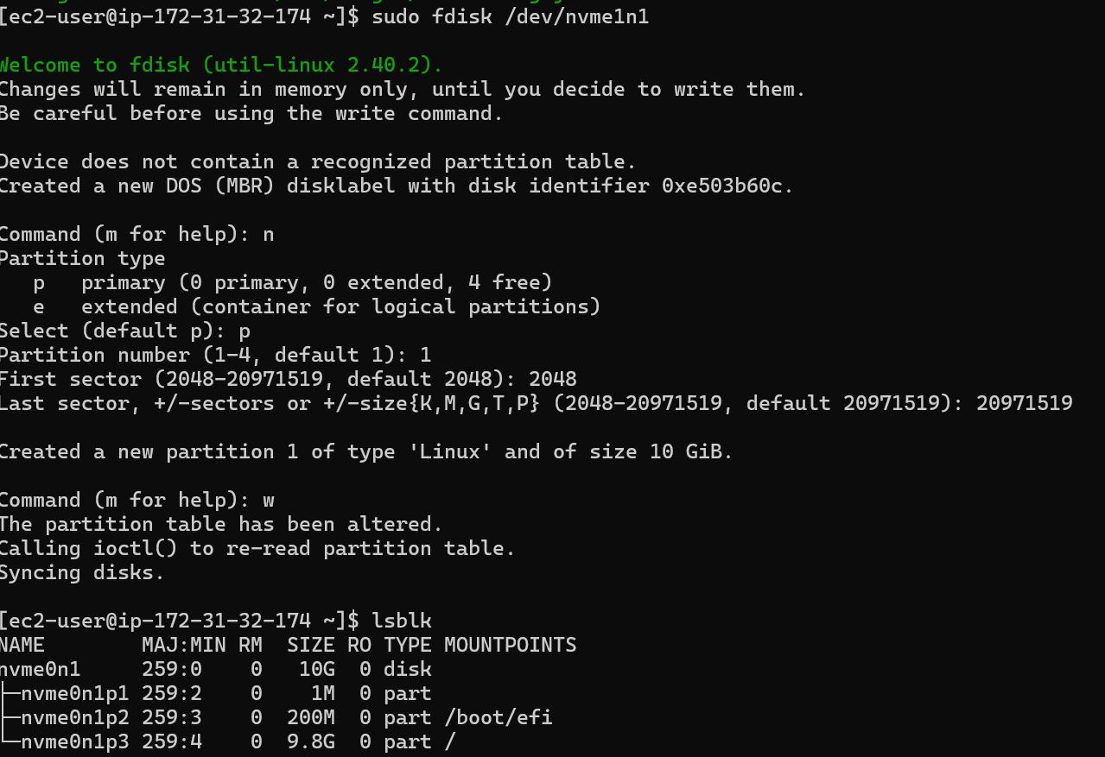
Step 35

Step 36: Create the Filesystem and Mount the Disk
What I did: I formatted the new partition with XFS and mounted it at /data.
Terminal note: Use the command/output shown in the screenshot as the record of this step.
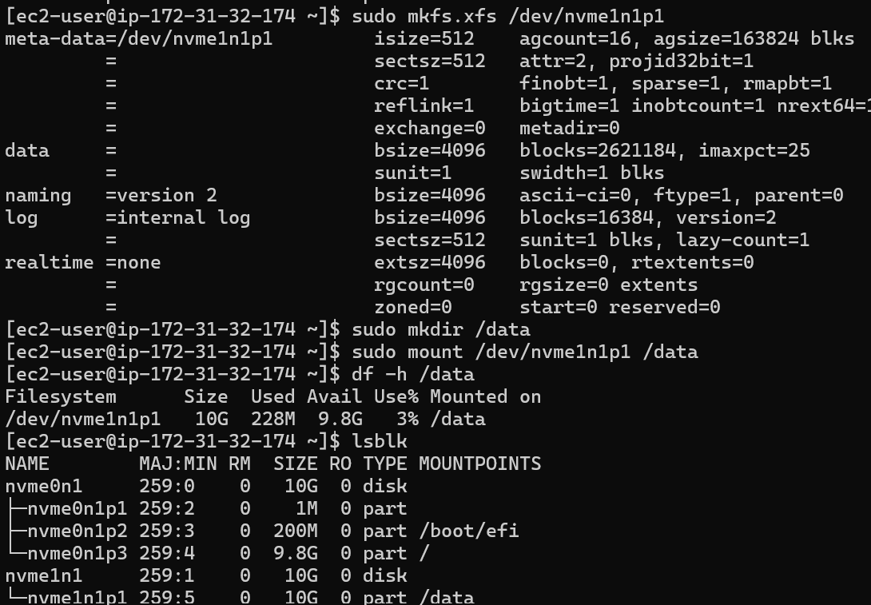
Step 36

Step 37: Install targetcli
What I did: I installed the targetcli package and its required dependencies for the iSCSI Target configuration.
Terminal note: Use the command/output shown in the screenshot as the record of this step.
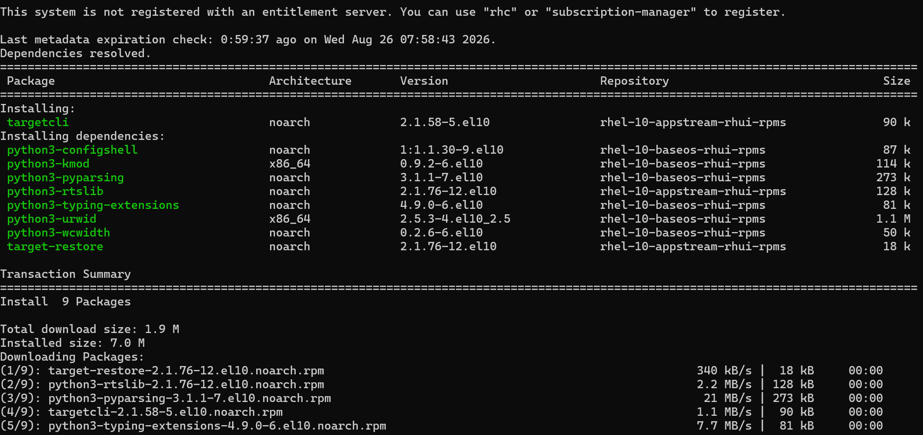
Step 37

Step 38: Verify iSCSI Target Tools
What I did: I ran targetcli with sudo and verified that the iSCSI target configuration tree was available.
Terminal note: Use the command/output shown in the screenshot as the record of this step.
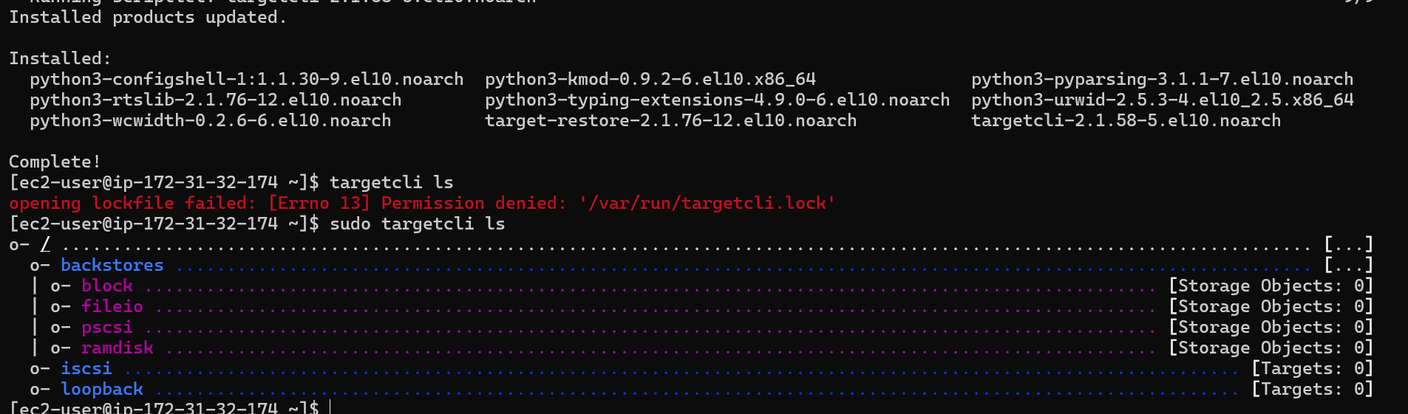
Step 38

SECTION 5 — FTP (SEPARATE TASK IN SOURCE FILE)
Step 39: Install vsftpd
What I did: I installed the vsftpd package for the separate FTP task shown in the screenshots.
Terminal note: Use the command/output shown in the screenshot as the record of this step.
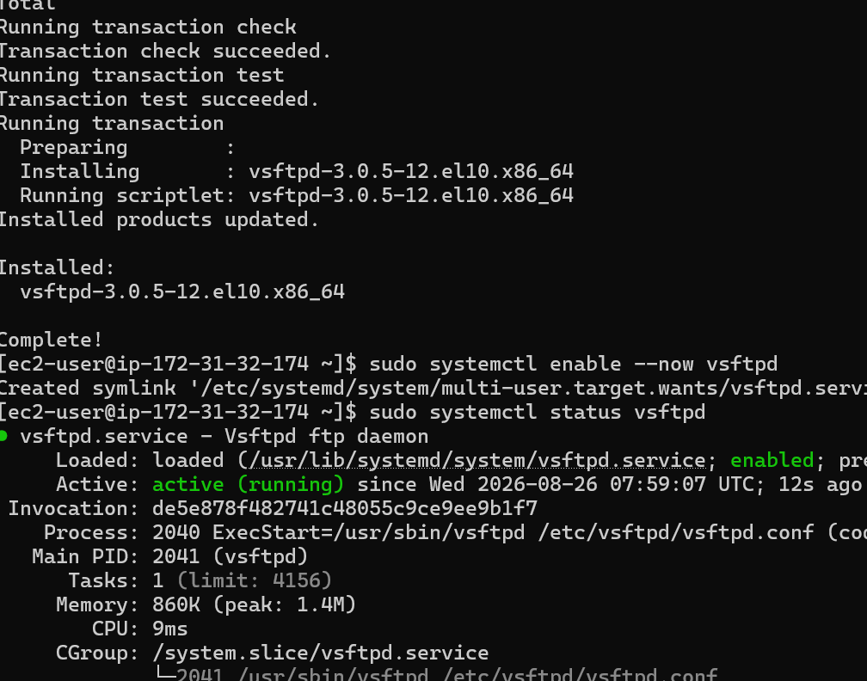
Step 39

Step 40: Enable and Verify vsftpd
What I did: I enabled and started vsftpd, then checked that the service was active.
Terminal note: Use the command/output shown in the screenshot as the record of this step.
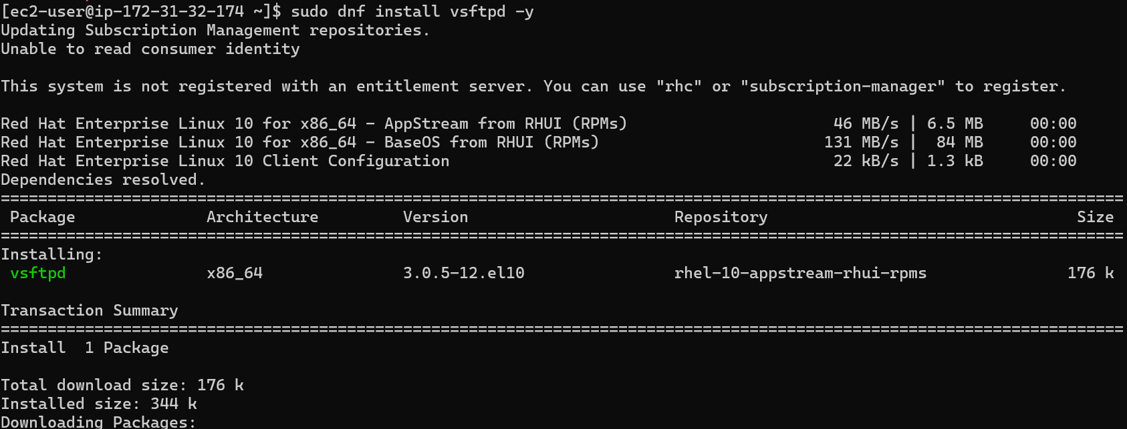
Step 40

Final Practical Flow
- AWS VPC/networking is reviewed first.
- RHEL EC2 instance is launched with a key pair and network/security settings.
- An EBS volume is created in the correct Availability Zone and attached to the RHEL instance.
- Windows SSH connectivity is tested and the PEM permissions are corrected.
- The new NVMe disk is verified in RHEL and partitioned/formatted as shown in the source screenshots.
- targetcli is installed and verified for the iSCSI Target configuration.
- The source file then shows the separate FTP installation/service steps.

